**SQL**

Create database customer

create table customers(id int PRIMARY key AUTO_INCREMENT, name varchar(100), cust_username varchar(100), password varchar(100),email varchar(100), mobile bigint(11), address varchar(255), pincode bigint(11))

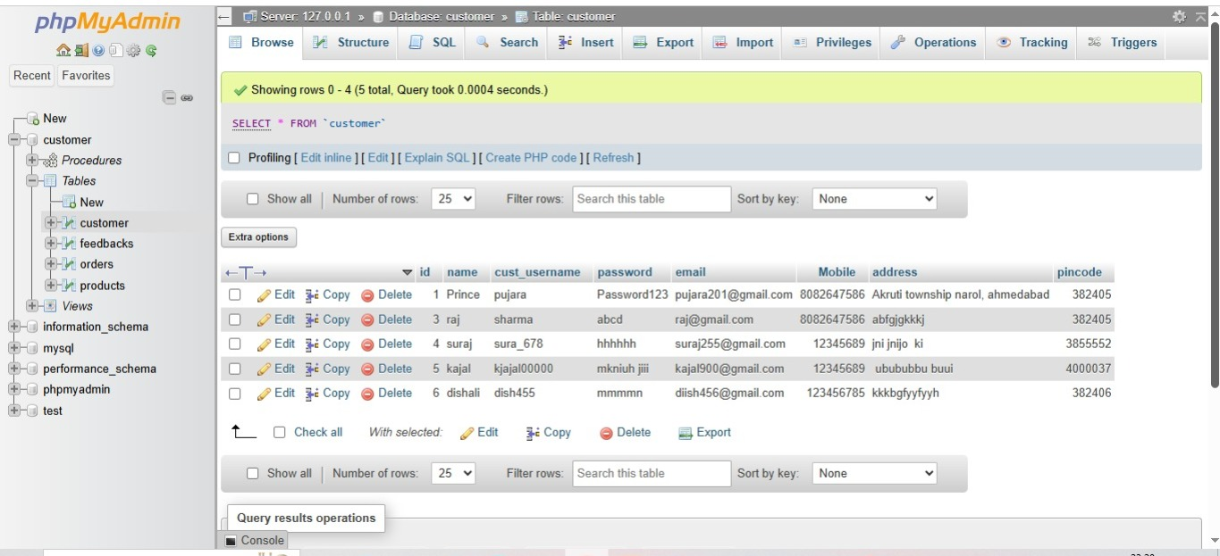

**1.SELECT:**

Syntax: Select * from customer where id=1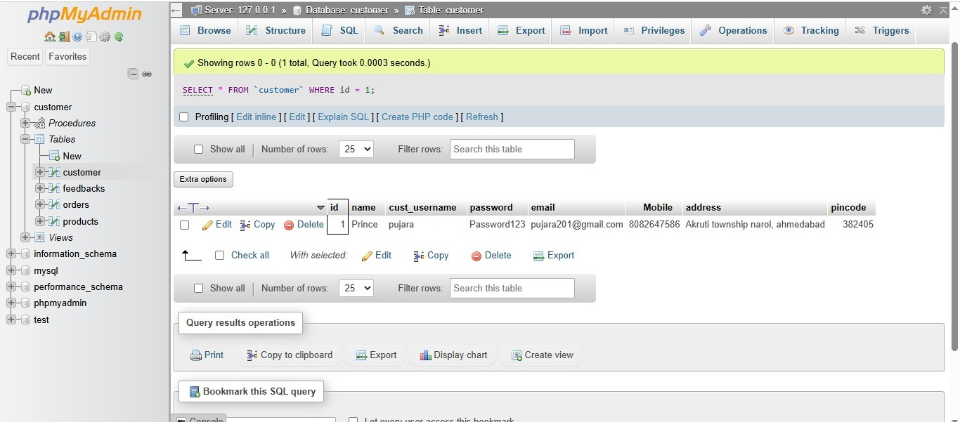

**2.** **UPDATE:**

UPDATE customer set name="pavan Nagar" , cust_username="nagar445", email="prav455@gmail.com" where id=3

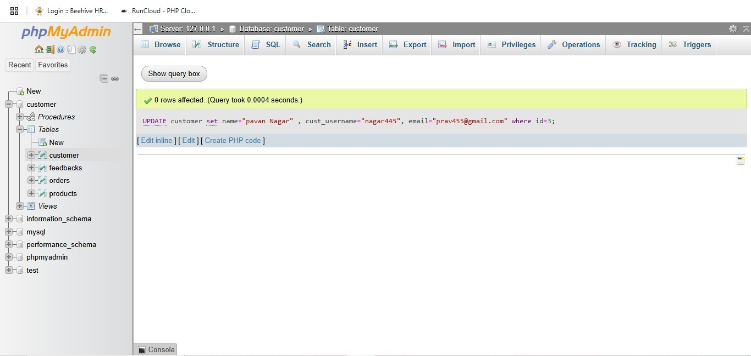

3**. DELETE:**

delete from products where id=3

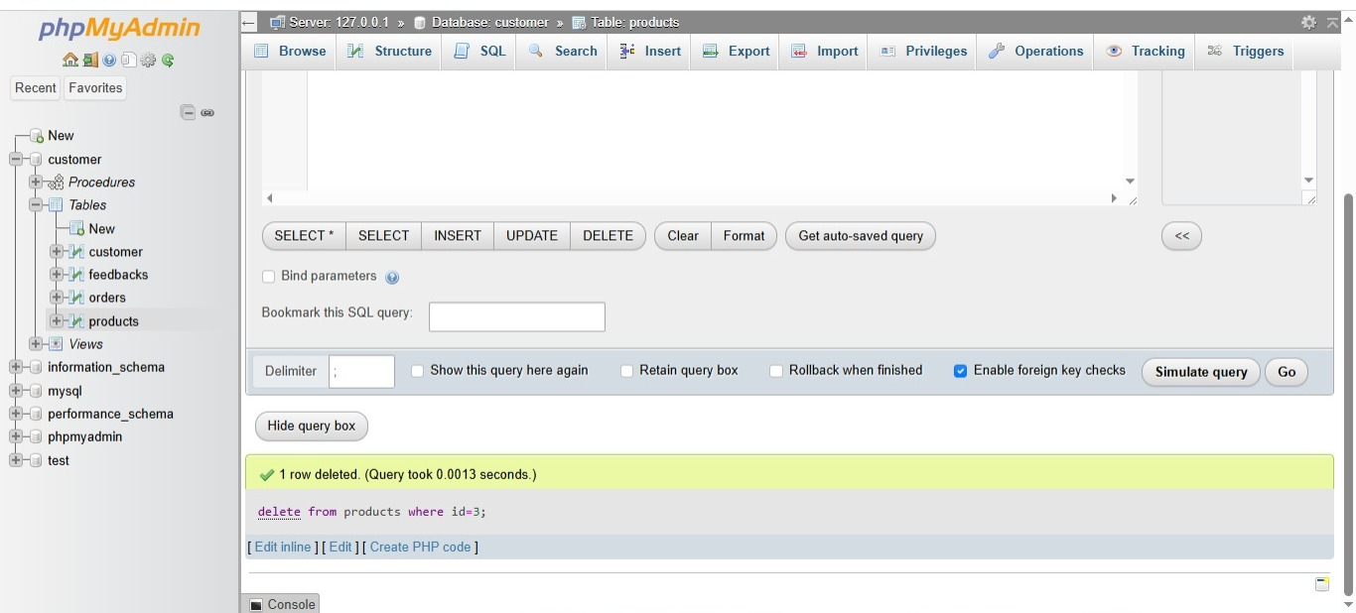

**4. Insert:**

insert into customer (name,cust_username,password,email,mobile,address,pincode) values("Akshay","akashay702","ghghg","akashay333@gmail.com","5646944","Ahmedabad","325874")

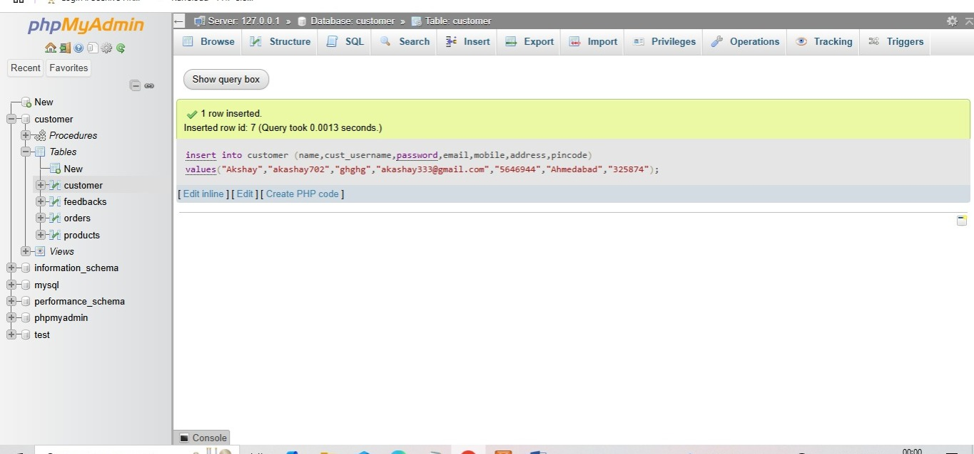

**WHERE:**

SELECT * FROM Customers WHERE CustomerID > 2

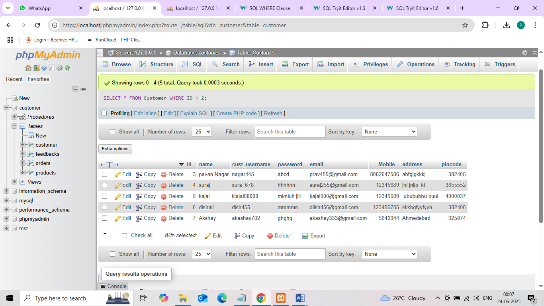

**LIKE:**

SELECT * FROM Customer

WHERE name LIKE 'a%';

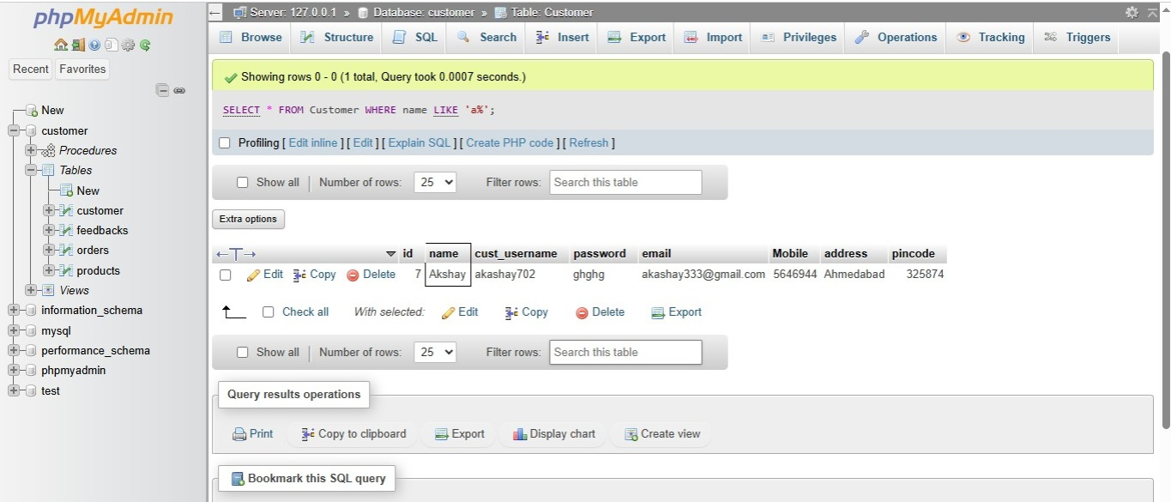

**GROUP BY:**

SELECT COUNT(id), Country

FROM orders

GROUP BY Country;

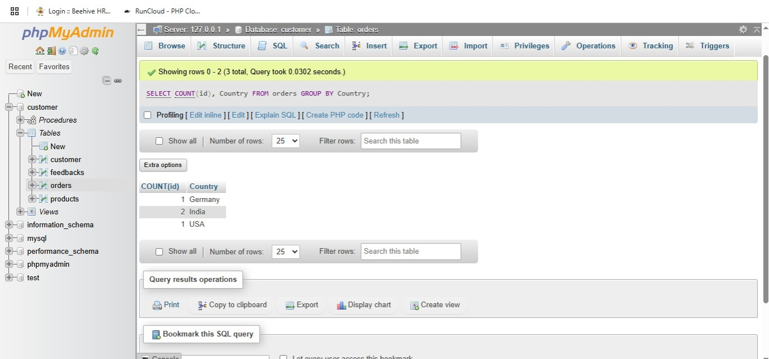

**HAVING:**

SELECT COUNT(id), Country

FROM orders

GROUP BY Country

HAVING COUNT(id) > 1

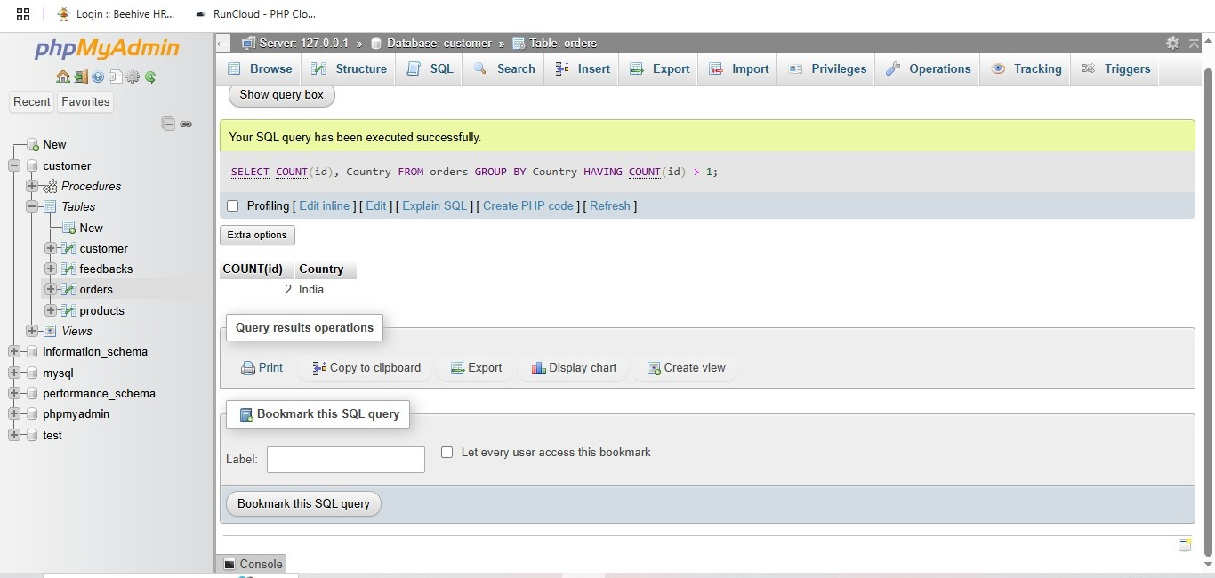

**LIMIT:**

SELECT * FROM Customer

LIMIT 3

;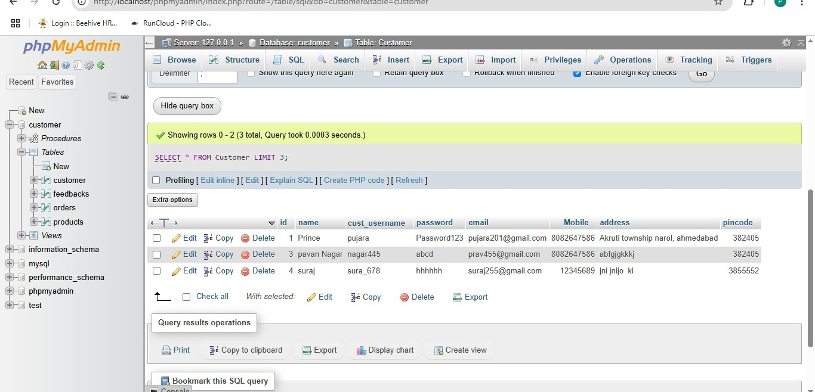

**OFFSET:**

- Select all columns for employees, starting from the 10th row

SELECT employee_id, first_name, last_name, phone_number, salary

FROM employees

-- Order by employee_id to ensure consistent ordering

ORDER BY employee_id

-- Skip the first 9 rows

OFFSET 9 ROWS;

**Subqueries:**

-SELECT NAME, LOCATION, PHONE_NUMBER

FROM DATABASE

WHERE ROLL_NO IN (

SELECT ROLL_NO FROM STUDENT WHERE SECTION='A'

);

**AND:**

SELECT *

FROM Customers

WHERE Country = 'Spain' AND CustomerName LIKE 'G%';

**OR:**

SELECT *

FROM Customers

WHERE Country = 'Germany' OR Country = 'Spain';

**NOT:**

SELECT * FROM Customers

WHERE NOT Country = 'India';

**IN:**

SELECT * FROM Customers

WHERE Country IN ('Germany', 'France', 'UK');